Download the data: <https://drive.google.com/file/d/1EsOsAb558l1LlSEWaMyAMJhv7mJD5K13/view?usp=sharing>

1. **Question:**

From the given data find the customer ID for the customers named “Kim West” and “Paul Hill”

**Answer:**

Type: =VLOOKUP(lookup_value, table_array, col_index_num, [range_lookup])

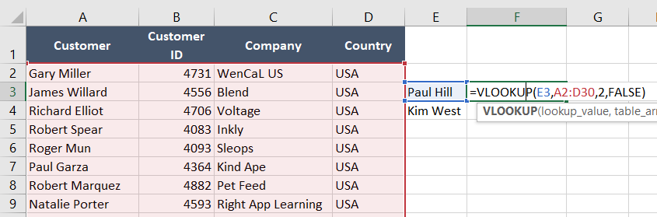

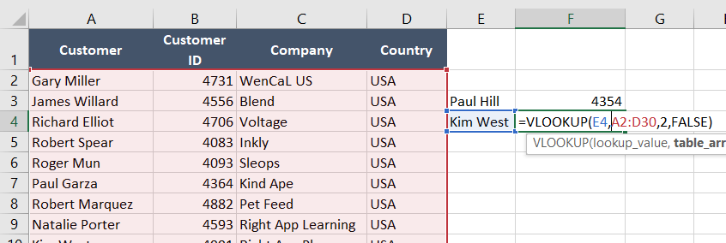

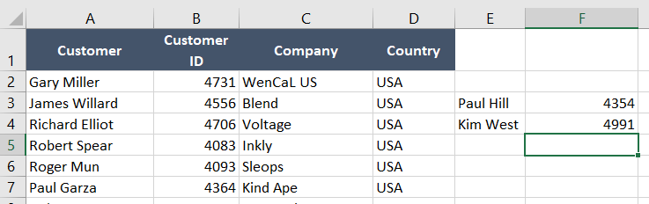

1. **Question:**

From the given data find the total marks of the George using HLOOKUP and print the each subjects marks of George by HLOOKUP

**Answer:**

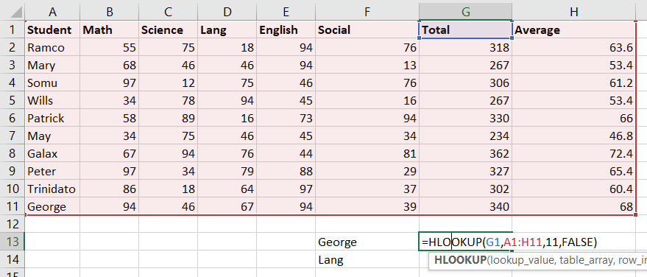

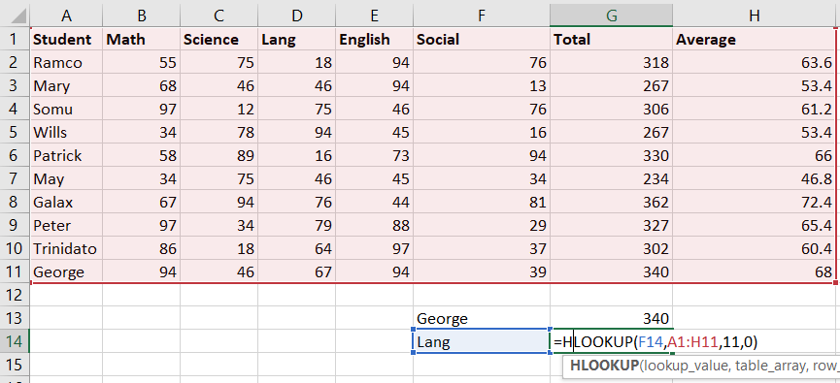

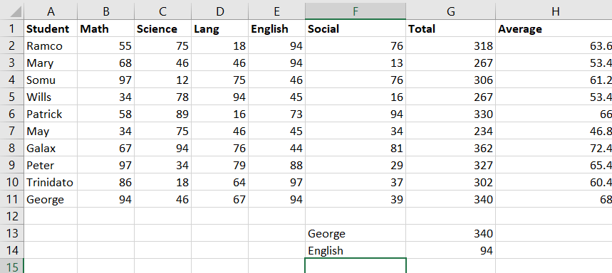

1. **Question:**

Create a lookup table containing scores and ratings based on the following categories:

0 - 4 = Pooh

5 - 9 = Could do better

10 - 14 = Doing better

15 or more = Tiggerific

Create a **VLOOKUP** function to calculate a rating for each player as follows:

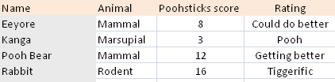

*The function should look up the score for each player*

Save the file with the same name and close it down.

**Answer:**

